Snowflake CLI

1.Basic CLI Usage
Check the Snowflake CLI version.
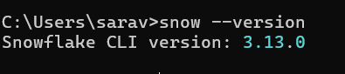
Test your connection to Snowflake using the CLI.
snow connection add
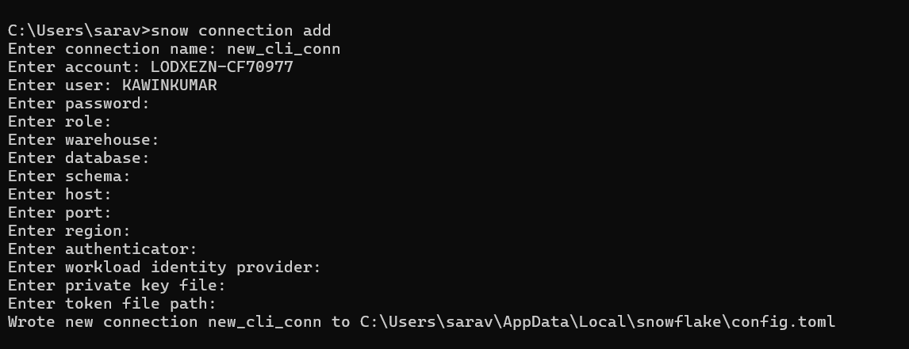
snow connection test -c snow_cli_conn
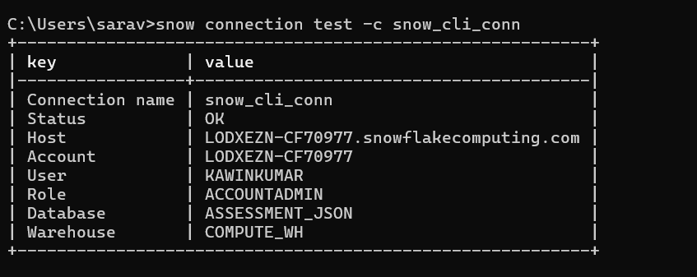

2. Running Simple SQL
Run a SQL command to show all databases.
snow sql -q "show databases;"
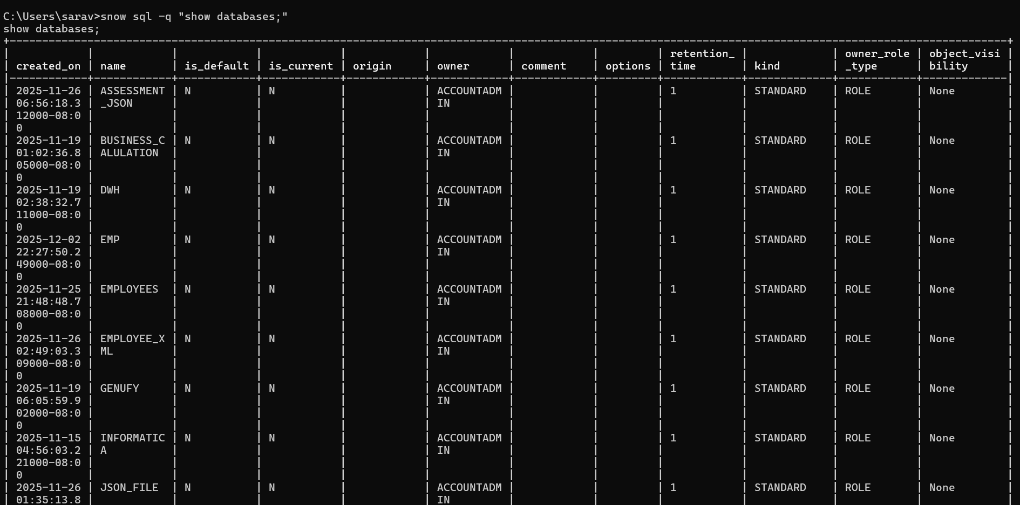
Run a SQL command to show all warehouses.
snow sql -q "show warehouses;"
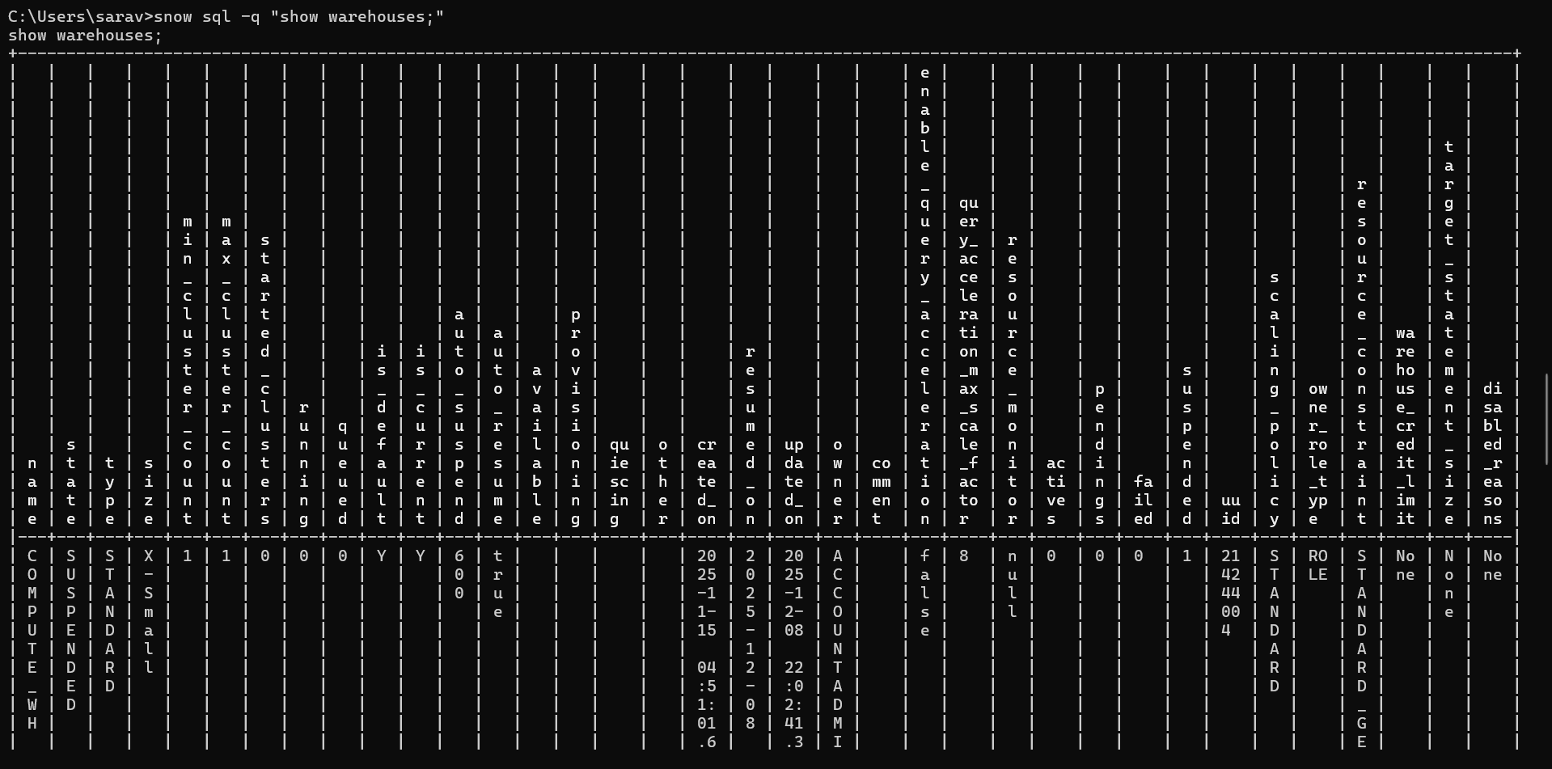

Run a SQL file using the Snowflake CLI.
snow sql -c new_cli_conn -f "C:\Users\sarav\Downloads\CLI_script.sql"
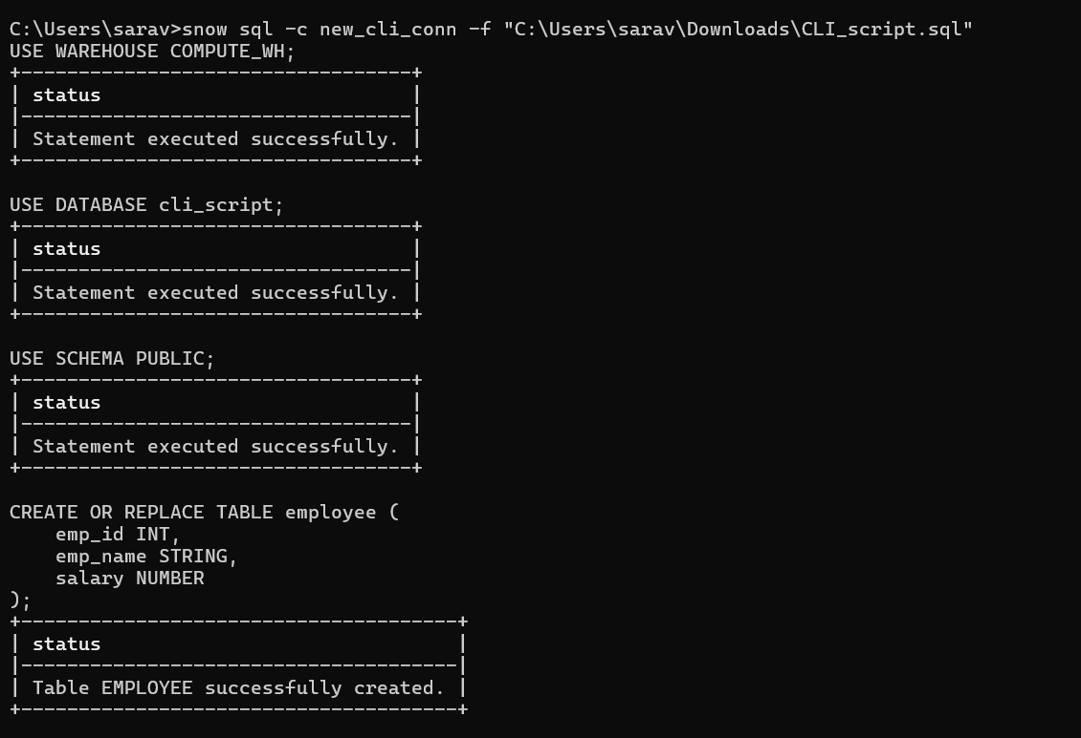 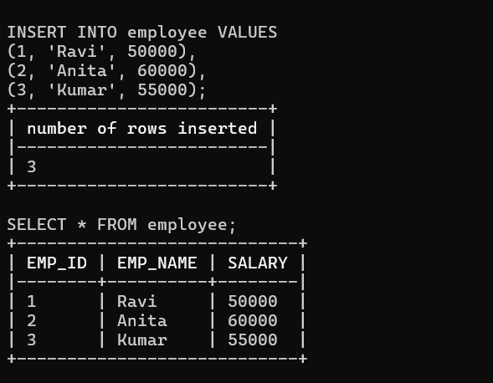
3. Creating Objects
Create a database using the CLI.
snow sql -q "create or replace database cli_script;"
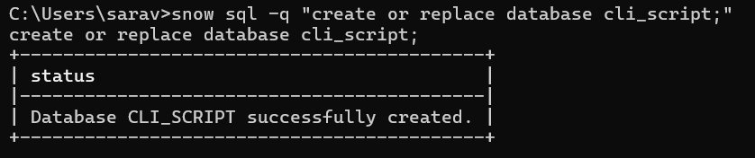
Create a schema inside that database.
snow sql -q "create or replace schema cli_script.sch_cli_script;"
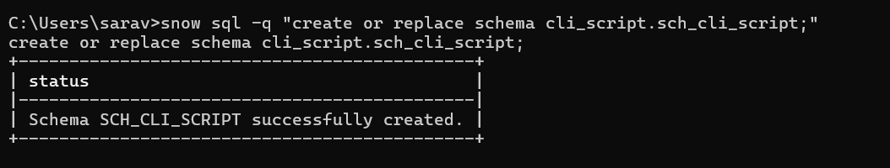

Create a table using a SQL file and run it through the CLI.
cd C:\Users\sarav\Downloads
snow sql -f CLI_script.sql
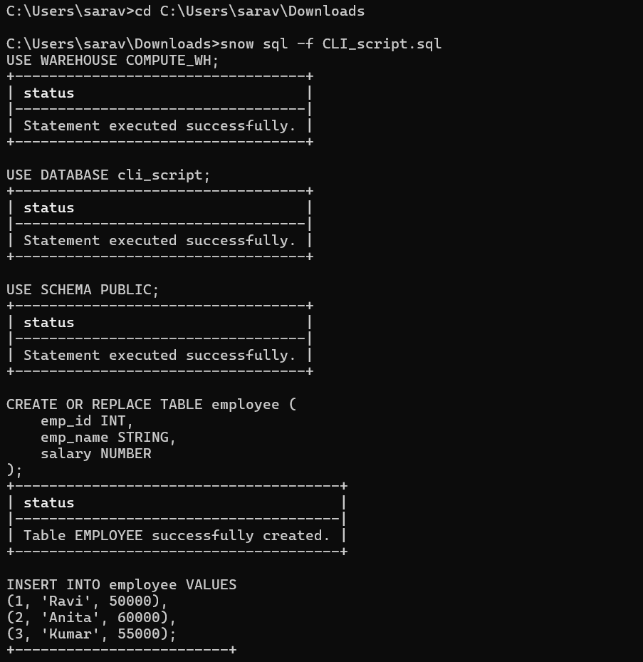
4. Working With Stages
Upload a small CSV file to an internal stage using the CLI.
snow sql -q "create or replace stage cli_script.SCH_CLI_SCRIPT.cli_internal;"
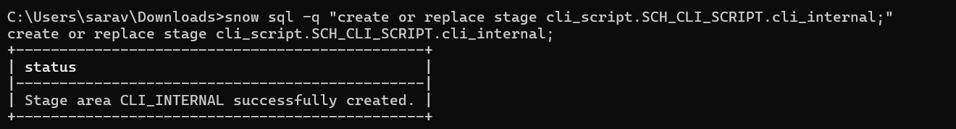
snow sql -q "put file://C:/Users/sarav/Downloads/CLI_script.sql @cli_script.SCH_CLI_SCRIPT.cli_internal;"
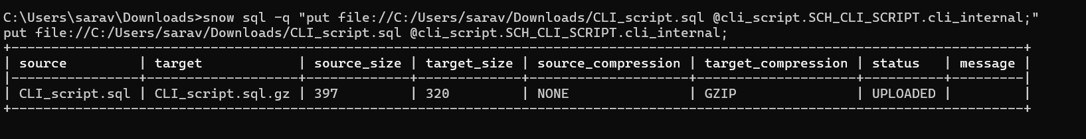
List the files inside the stage.
snow sql -q "list @cli_script.SCH_CLI_SCRIPT.cli_internal;"
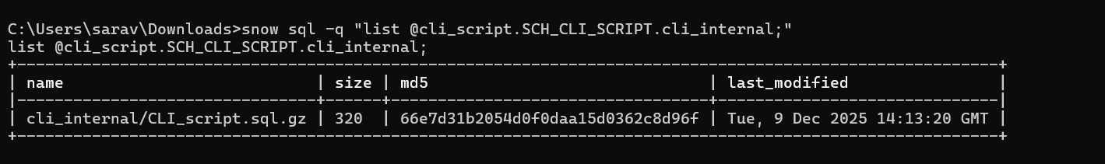
Download the uploaded file back to your computer.
snow sql -q "get @cli_script.SCH_CLI_SCRIPT.cli_internal/CLI_script.sql file://C:/Users/sarav/Downloads;"
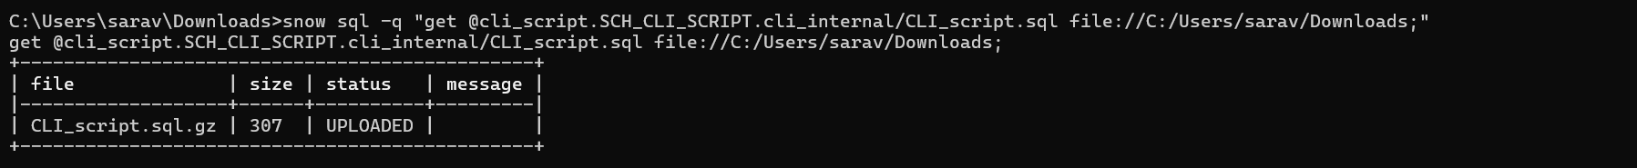

5.Loading and Unloading Data
Load CSV data into a table using COPY INTO via the CLI.
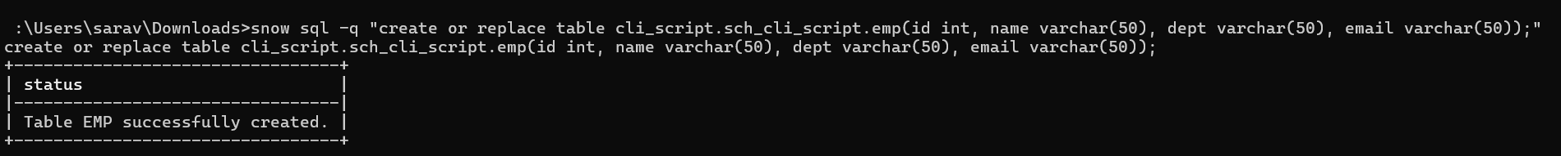
snow sql -q "COPY INTO cli_script.sch_cli_script.emp FROM @cli_script.sch_cli_script.cli_internal FILE_FORMAT = (TYPE = CSV SKIP_HEADER = 1) ON_ERROR = 'CONTINUE';"
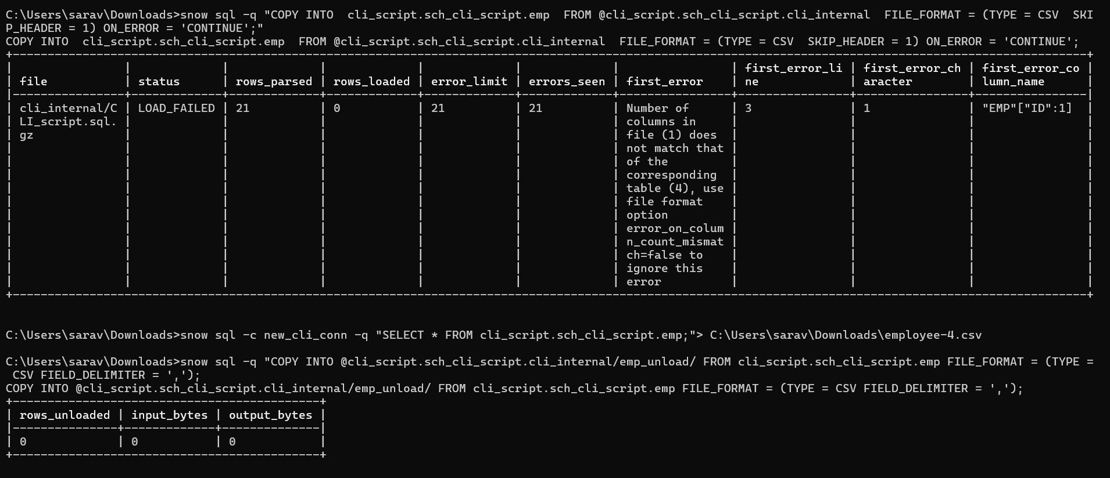

6. Deploying a Snowflake Project
Initialize a Snowflake project using snow init.
Deploy the project using snow deploy.
7.Query Output Practice
Run a SELECT query and save the results to a CSV file using the CLI.
snow sql -c new_cli_conn -q "SELECT * FROM cli_script.sch_cli_script.emp;"> C:/Users/sarav/Downloads/employee-4.csv"
Try different output formats such as pretty, CSV, and JSON.
8. Playing With Context
Change the warehouse while running a query.
snow sql -q "USE WAREHOUSE COMPUTE_WH; SELECT * FROM cli_script.sch_cli_script.emp;"
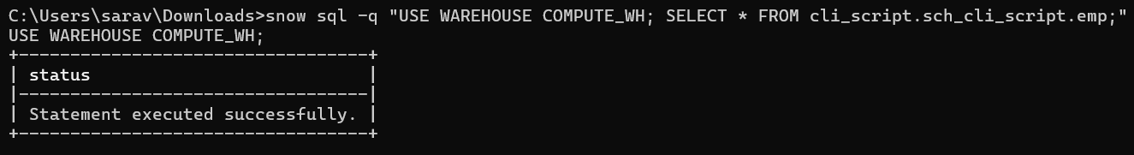

9. Troubleshooting and Help
Use the help command to list all available CLI commands.
snow stage –help
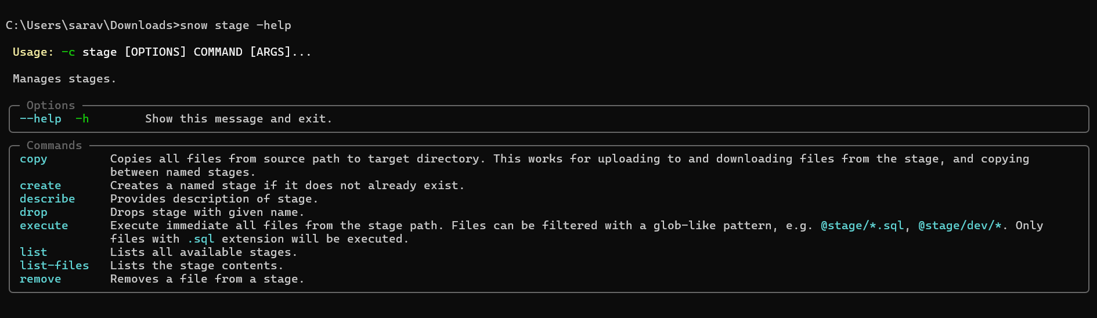

Run a command in verbose mode to view detailed logs.
set SNOWFLAKE_CLI_LOG_LEVEL=DEBUG
snow sql -q "SELECT CURRENT_TIMESTAMP();"
